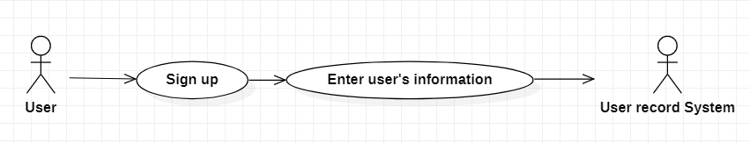

|  |  |
| --- | --- |
| **Sign up** | |
| Actors | User, user record system |
| Description | User send user’s information such as username, password, profile,… to the user record system with the command that insert this user to the database |
| Data | Id, username, password, phone, avatar, address,… |
| Stimulus | Interface that include create new user information form; sign up button and cancel button |
| Response | Message that: confirm create successful or fail (kind of error) |
| Comments | Password need to have more 10 characters |